**HOOL**

**CAPSTONE PROJECT 1**

**CMU-CS 246 HIS**

**USER INTERFACE DESIGN DOCUMENT**

Version: 1.1

**E – CALCULATOR APPLICATION - ECA**

**Mentor: Nguyen Dang Quang Huy**

***Team Member*:**

Quy, Tran

Thuyen, Tran An

Duong, Tran Thi Thuy

Tuan, Le Minh

Huy, Nguyen Anh

**Approved by Huy Nguyen Dang Quang**

**UserInterface Review Panel Representative:**

Name Signature Date

**Capstone Project 1- Mentor:**

Name Signature Date

Da Nang, 01/2024

**PROJECT INFORMATION**

| **Project Acronym** | ECA |
| --- | --- |
| **Project Title** | E-Calculator Application | | | |
| **Start Date** | Jan 25th, 2024 | **End Date** | Feb 22th, 2024 | |
| **Lead Institution** | International School, Duy Tan University | | | |
| **Team Member** | **Name** | **Email** | | **Phone** |
| 28211104518 | Tran Quy | tquy5453@gmail.com | | 0396751590 |
| 28212223967 | Le Minh Tuan | leminhtuank0@gmail.com | | 0762528509 |
| 28204645936 | Tran Thi Thuy Duong | thuyduong0796646477@gmail.com | | 0796646477 |
| 28211351997 | Tran An Thuyen | trananthuyen1902@gmail.com | | 0918308551 |
| 28210205517 | Nguyen Anh Huy | anhhuynguyenqn23@gmail.com | | 0896216239 |



**INTERNATIONAL SC**

**PROJECT PLAN DOCUMENT**

| **Document Title** | User Interface Document | | |
| --- | --- | --- | --- |
| **Author(s)** | C1CS.5 Team | | |
| **Date** | Jan 30th, 2024 | **File name:** | TEAM 5-USER-INTERRFACE-DESIGN-DOCUMENT.docx |
| **URL** | <https://drive.google.com/drive/folders/1sptzDQrhTWR7qHZarDmqxk_RCaLTLb0S?usp=sharing> | | |
| **Access** | Project and CMU Program | | |

**SIGNATURE**

**Document Approvals:** The following signatures are required for approval of this document.

| **Mentor** | Huy, Nguyen Dang Quang | **Signature:** |  |
| --- | --- | --- | --- |
| **Date:** |  |
| **Leader** | Quy, Tran | **Signature:** |  |
| **Date:** |  |
| **Team member(s)** | Tuan, Le Minh | **Signature:** |  |
| **Date:** |  |
| Duong, Tran Thi Thuy | **Signature:** |  |
| **Date:** |  |
| Thuyen, Tran An | **Signature:** |  |
| **Date:** |  |
|  | Huy, Nguyen Anh | **Signature:** |  |
|  | **Date:** |  |

**DOCUMENT HISTORY**

| **Version** | **Person(s)** | **Date** | **Description** |
| --- | --- | --- | --- |
| **1.0** | All members | Jan 26th, 2024 | Draft |
| **1.1** | Duong, Tran Thi Thuy | Jan 30th, 2024 | Final |

**TABLE OF CONTENTS**

**I.** **INTRODUCTION 5**

**1. PURPOSE 5**

**2. SCOPE 5**

**II.** **LIST OF USER INTERFACE 5**

**1. BUSINESS FUNCTION DIAGRAM: 5**

**2. INTERFACE APP: 6**

**III.** **DESCRIBE USER INTERFACE 8**

**1. E – CALCULATOR APPLICATION PAGE 8**

**TABLES**

**Table 1: List of Interface 6**

**Table 2: Describe User Interface ECA page 8**

# INTRODUCTION

## PURPOSE

* The porpose of this project is to create a calculator application that can input any two numbers and perform the following operations: +, -, *, / and % on the two input numbers.

## SCOPE

* Input any two numbers from the user.
* Perform the operations of addition, sudtraction, multiplication, division, and remainder for the two input numbers.
* Display scope the results of the operations on a form.

# LIST OF USER INTERFACE

## BUSINESS FUNCTION DIAGRAM:

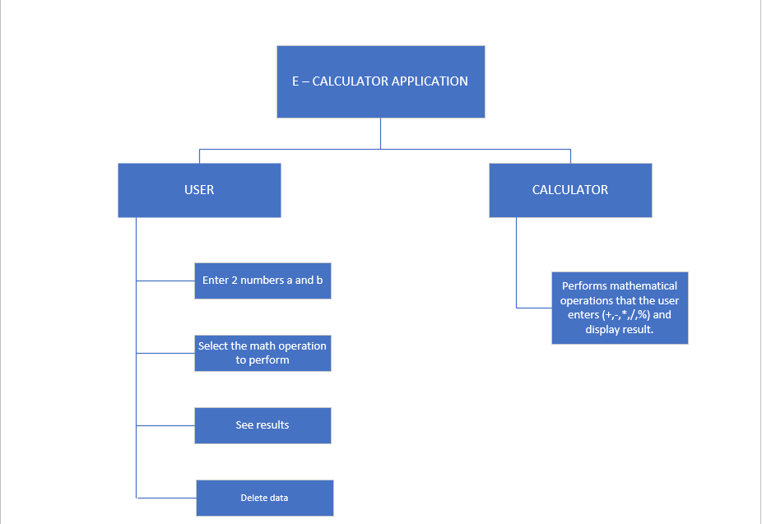

*Figure 1: Business Function diagram*

## INTERFACE APP:

| **User Interface ID** | **UI Name** | **Description** |
| --- | --- | --- |
| UI-01 | Enter 2 number a and b | Enter will be used as a function that allows users to enter any two numbers into the system |
| UI-02 | Select the math operation to perform | Allows users to choose the calculation they want to perform |
| UI-03 | See result | The results will be displayed and users can see the results of their calculations |
| UI-04 | Delete data | User can delete data to perform another calculation |
| UI-05 | Performs mathematical operations that the user enters (+, -, *, /, %) and display result | The system will perform the calculation and display the results |

***Table 1****: List of Interface*

# DESCRIBE USER INTERFACE

## E – CALCULATOR APPLICATION PAGE:

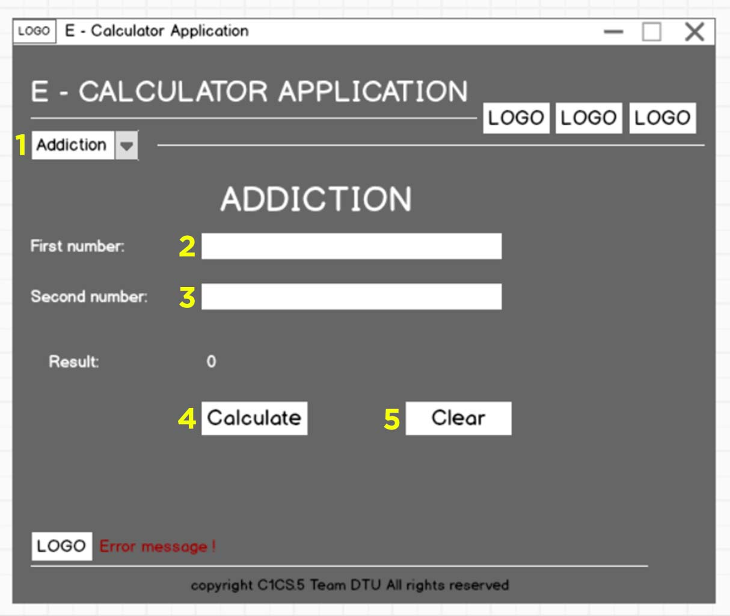

| **ID** | **Condition** | **Control Type** | **Target** |
| --- | --- | --- | --- |
| 1 | Press | Combo box | Select the calculation you want to perform |
| 2 | Press | Input text | Enter a number |
| 3 | Press | Input text | Enter a number |
| 4 | Press | Button | Click to perform the calculation |
| 5 | Press | Button | Refresh to perform the new calculation desired by the user |

***Table 2****: Describe User Interface ECA Page.*